# Application Design

As part of the design phase of the application I went through a process of creating flow diagrams to describe the way the application should work.

## Activity/flow diagrams

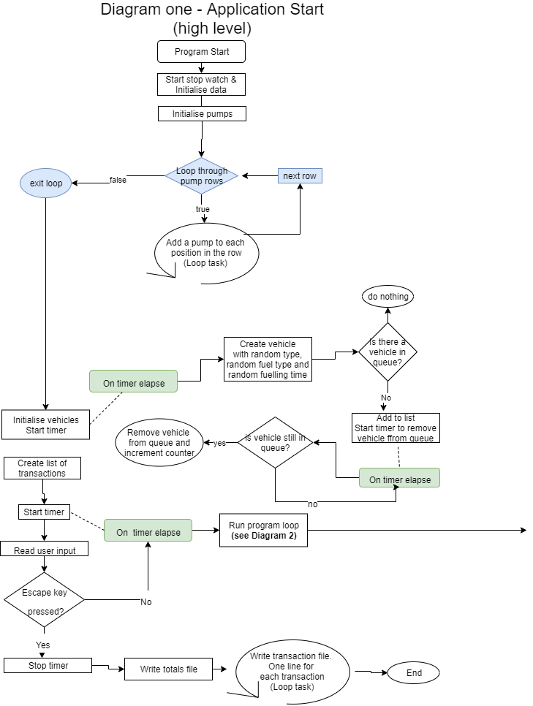

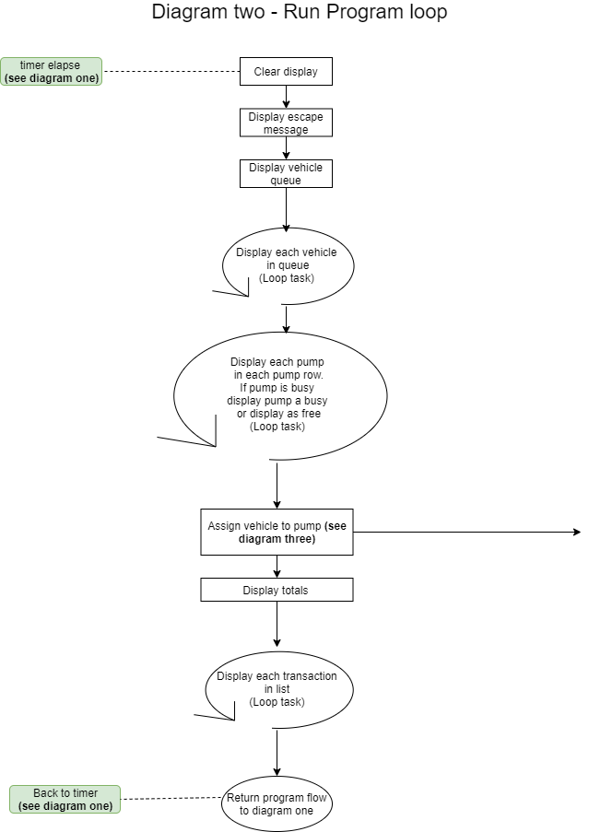

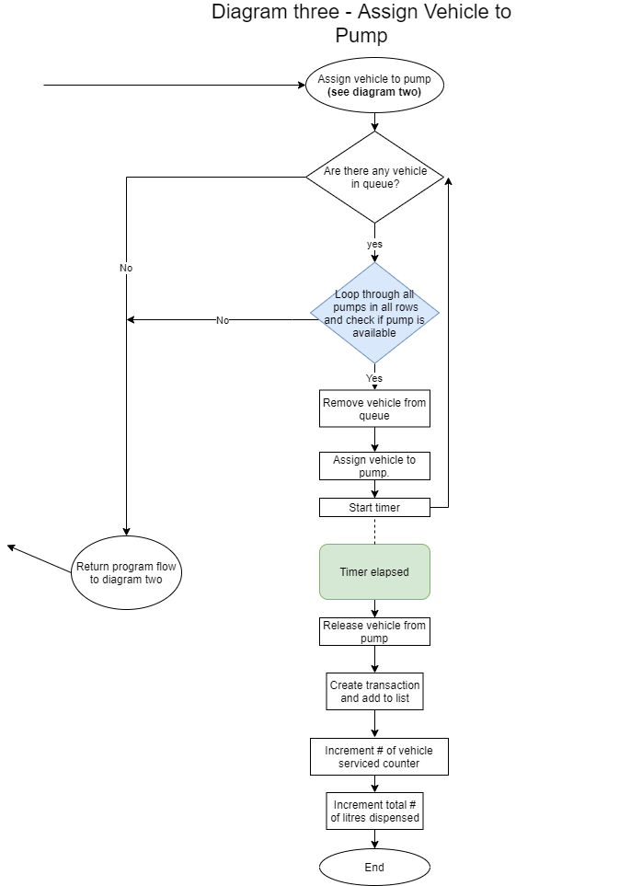

## Pseudo code

Start application

Initiialise data

Create 3 rows of pumps

LOOP 3 times for each pump row (to create 3x3)

Create new pump, assign fuel types and give unique number

Add pump to row of pumps

END LOOP

Create (queue) list of vehicles

Create new vehicle at random interval using timer

Create and random fuel type

Create a random vehicle

Add vehicle to vehicle list (queue)

IF (time exceeds limit for vehicle in queue)

IF (there is vehicle in queue)

Remove vehicle from list (queue)

Increment counter for vehicles not serviced

END IF

END IF

Create a list of transactions

Set up timer to run main program loop

LOOP every 0.5 seconds

Clear UI display

Display UI elements

Clear UI

Display Message

LOOP for each vehicle in queue // DRAW VEHICLES

Display vehicle on console

END LOOP

LOOP 3 times for each pump row (to create 3x3)

IF (pump is available)

Display pump as available

ELSE

Display pump as busy

END IF

END LOOP

Display totals

LOOP for each transaction in list

Display Transactions

END LOOP

Assign vehicle to pump

IF (there are no vehicle in queue) //ASSIGN VEHICLE TO PUMP

return

END IF

Check third pump row to begin with

IF (pump 3 is available AND pump 1 and pump 2 are available)

Remove vehicle from queue

Assign to pump 3

Release vehicle from pump when fuelled

Create transaction

Increment vehicle serviced counter

Increment total litres sold for fuel type

END IF

IF (there are no vehicle in queue)

EXIT LOOP

END IF

IF (pump 3 is NOT available AND pump 1 and pump 2 are available)

Remove vehicle from queue

Assign to pump 2

Release vehicle from pump when fuelled

Create transaction

Increment vehicle serviced counter

Increment total litres sold for fuel type

END IF

IF (there are no vehicle in queue)

EXIT LOOP

END IF

IF (pump 3 is NOT available AND pump 2 is NOT available and pump 1 is available)

Remove vehicle from queue

Assign to pump 1

Release vehicle from pump when fuelled

Create transaction

Increment vehicle serviced counter

Increment total litres sold for fuel type

END IF

IF (there are no vehicle in queue)

EXIT LOOP

END IF

Check second pump row as for row 3 above

Check first pump row as for row 3 above

IF (user presses escape key)

Stop timer

Write output files

Write totals to Totals file

LOOP all transactions in list

Write transaction to Transactions file

END LOOP

END IF

END LOOP